**Seminar Report**

**On**

Cleaning Robots

**Vagge Reema Rani 19261A04B9**



**Department of Electronics and Communication Engineering**

# MAHATMA GANDHI INSTITUTTE OF TECHNOLOGY

## (Affiliated to Jawaharlal Nehru Technological University, Hyderabad)

**Chaitanya Bharathi P.O., Gandipet, Hyderabad – 500 075**

**2022 – 2023**

**CLEANING ROBOTS**

**Seminar Report**

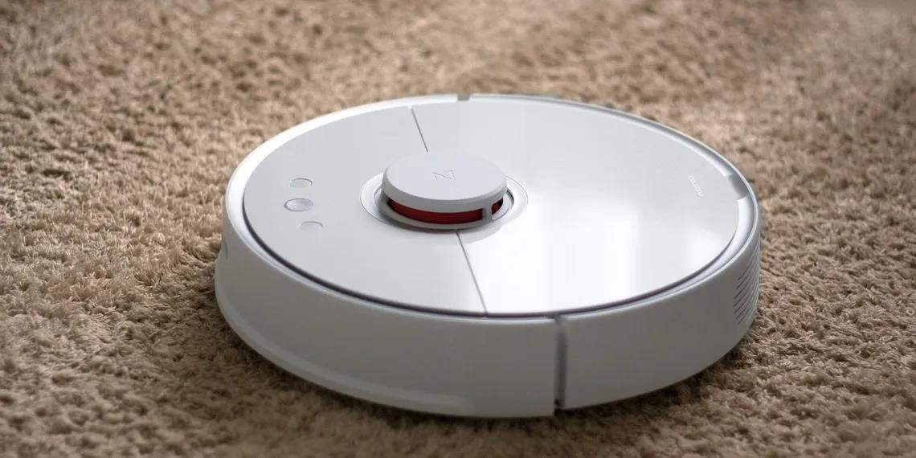

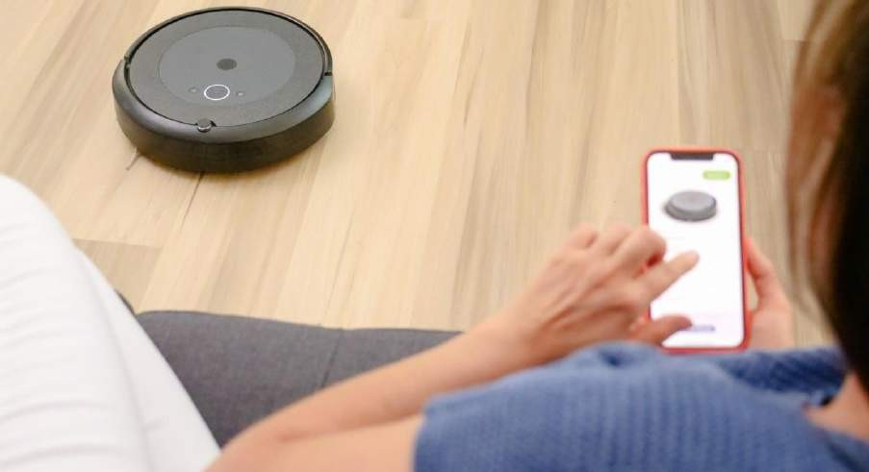



**TABLE OF CONTENTS**

**INDEX:**

* **ABSTRACT**
* **INTRODUCTION**

### What are Cleaning Robots

* **HISTORY**
* **SELF-CLEANING ROBOT TECHNOLOGY FEATURES**
  + **Vacuum cleaning robots**
  + **Disinfectant-spraying robots**
  + **UV-C robots**
* **HOW DOES A CLEANING ROBOT WORK**
  + **Onboard Sensors**
  + **Great Accessibility**
  + **Compact size and design**
* **HOW ARE CLEANING ROBOTS MADE UP OF?**
* **MECHANISM OF CLEANING ROBOTS**
* **HOW DO CLEANING ROBOTS NAVIGATE?**
* **MAIN FEATURES OF CLEANING ROBOTS**
* **ADVANTAGES**
* **DISADVANTAGES**
* **APPLICATIONS**
* **THE FUTURE OF SELF-CLEANING ROBOTS**
* **CONCLUSION**
* **REFERENCES**



# ABSTRACT

Robot Vacuum Cleaners are the smart devices that take care of your cleaning chores with just a single click. Equipped to clean an entire floor and covering difficult corners, they are perfect appliance for people who find it difficult to take out time for sweeping and cleaning. In an Indian setting, this job is still taken care of by the house help. Buying this appliance will reduce your dependency on them and the process can be taken care of without time constraints.

Robot vacuum cleaner is a smart home appliance which cleans the floor automatically. The main features of a Cleaning Robots cleaner are environment mapping, anti-drop, obstacle climbing & auto-recharge. Technically speaking, it uses simultaneous localization and mapping (SLAM) using the laser distance sensor (LDS) on the top of its body, its bumpers, and an infrared sensor to detect and avoid obstacles in its path.

Today’s Cleaning Robots cleaners are smarter and more affordable. Most models map home layouts allowing faster cleaning, and they can automatically dump the dust and even return to the charging station to recharge themselves. These futuristic devices require minimal human intervention and watching them work feels like magic. At its basic form, robots can carry out repetitive actions. As technology advances, they have higher intelligence and autonomy to do jobs faster with increased productivity.

Cleaning companies today have gone beyond just using mops and brooms to carry out their services. The use of robot cleaning machines will not only reduce the amount of physical labour it takes for cleaning jobs but also enhances efficiency. Businesses can expect to also reduce their water and chemical usage, increase the accuracy of chemical dosing, and improve hygiene compliance.

First part of this seminar is a physical overview of cleaning robots and it’s working along with the components and sensors used in it. Second part of seminar deals with mechanism of cleaning robots. Then it offers some technical facts, and so present and future aspects of use in actual products.

Finally, we investigate the advantages, disadvantages, applications and future scope of Cleaning Robots. This report will give you the overall working, applications of Cleaning Robots.



# INTRODUCTION

A Cleaning Robots is a self-propelled floor cleaner that uses brushes, a rotating brush, or an air-driven turbine to pick up dirt and debris from carpets and hard floors. They work on their own without any human intervention.

Robo-vacs have sensors to detect obstacles in the way, such as furniture, doorways, and stairs, so that they can navigate around them. They are designed for those who want to do less housework but still maintain cleanliness in their homes.

Cleaning Robots are either corded or cordless, have different brush types for different surfaces, and run-on electricity or rechargeable batteries.

## What are Cleaning Robots

Cleaning Robots clean your carpet and floors the same way traditional vacuums do brushing and sucking up dirt. However, Robo-vacs can do this without any human intervention through the help of sensors.

High-end Cleaning Robots use infrared lasers to navigate spaces, while cheaper models map the floor using physical boundary stripes. Using either sensor, robot vacs can detect obstacles, measure the distance they’ve travelled, detect hazards, and find new areas to clean.

The sensors a Cleaning Robots uses and how it works depend on the manufacturer and

the device model, but what’s common is the use of sensors to navigate spaces.

Cleaning Robots are a must-have for those who have difficulty using traditional vacuums or would like to save time cleaning their homes.

Cleaning Robots are more popular than ever as people try to find ways to clean their homes with less effort. They save time and effort for those who don't want to spend their weekends trying to clean up after themselves.

If you’re like most people, you might be wondering how these helpful devices work.

Well, we’ve got you covered.



# HISTORY

* In 1956, the American science fiction author [Robert A. Heinlein](https://en.m.wikipedia.org/wiki/Robert_A._Heinlein) described the concept of a Cleaning Robots cleaner with a recharging dock in his novel [The](https://en.m.wikipedia.org/wiki/The_Door_into_Summer) [Door into Summer](https://en.m.wikipedia.org/wiki/The_Door_into_Summer): "Basically it was just a better vacuum cleaner .... It went quietly looking for dirt all day long, in search curves that could miss nothing .... Around dinner time it would go to its stall and soak up a quick charge."



* In 1969 on 2 April an episode of [The Avengers](https://en.m.wikipedia.org/wiki/The_Avengers_(TV_programme)) was broadcast in which the character Inge Tilson played by Dora Reisser says "...I saw a demonstration once. A robot vacuum cleaner. It swept around the house, went back into its cupboard, automatically plugged in and recharged itself...". The teleplay for this episode which was entitled "Thingumajig" was written by [Terry Nation](https://en.m.wikipedia.org/wiki/Terry_Nation). It was episode 27 of Season 7.
* In 1990, three roboticists, Colin Angle, Helen Greiner, and Rodney Brooks, founded [iRobot](https://en.m.wikipedia.org/wiki/IRobot). It was originally dedicated to making robots for military and domestic use. It launched the [Roomba](https://en.m.wikipedia.org/wiki/Roomba) in 2002, which was able to change direction when it encountered an obstacle, detect dirty spots on the floor, and identify steep drops to keep it from falling down stairs. The Roomba proved to be the first commercially successful robot vacuum.
* In 2005, iRobot introduced the [Scooba](https://en.m.wikipedia.org/wiki/Scooba_(brand)), which [scrubbed](https://en.m.wikipedia.org/wiki/Floor-scrubbing_robot) hard floors.



* In 1996, [Electrolux](https://en.m.wikipedia.org/wiki/Electrolux) introduced the first “Cleaning Robots Cleaner”, the [Electrolux Trilobite](https://en.m.wikipedia.org/wiki/Electrolux_Trilobite). It worked well but had frequent problems with colliding with objects and stopping short of walls and other objects, as well as leaving small areas not cleaned. As a result, it failed in the market and was discontinued.
* In 1997, one of Electrolux's first versions of the Trilobite vacuum was featured on the [BBC'](https://en.m.wikipedia.org/wiki/BBC)s science program, [Tomorrow's World](https://en.m.wikipedia.org/wiki/Tomorrow%27s_World).
* In 2001, [Dyson](https://en.m.wikipedia.org/wiki/Dyson_(company)) built and demonstrated a robot vacuum known as the DC06. However, due to its high price, it was never released to the market. Electrolux Released the Trilobite Cleaning Robots cleaner. The Cleaning Robots cleaner launched at a price of $1,800.00. There were two models: The ZA1 and the ZA2.
* In 2010, the [Neato Robotics](https://en.m.wikipedia.org/wiki/Neato_Robotics) XV-11 Cleaning Robots introduced [laser](https://en.m.wikipedia.org/wiki/Laser_rangefinder) [based](https://en.m.wikipedia.org/wiki/Laser_rangefinder) mapping, allowing [navigation](https://en.m.wikipedia.org/wiki/Robot_navigation) in straight lines rather than the traditional random navigation.
* In 2015, Dyson and iRobot both introduced camera-based mapping.
* In 2016, [iRobot](https://en.m.wikipedia.org/wiki/IRobot) CEO claimed that 20% of vacuum cleaner’s sales worldwide were robots.
* As of 2018, obstacles such as dog faces, cables and shoes remain very difficult for robots to navigate around.



# SELF-CLEANING ROBOT TECHNOLOGY FEATURES

The robotics market in India is growing rapidly. Many Indian start-ups and IT companies are successfully venturing into AI-driven enterprises, a latest report by the International Federation of Robotics (IFR) places India amongst the Top 10 countries of annual installation of robots in industry dominated areas.

The multi-pronged uses of robots allow them to be used in different domains. From hospitality to hospitals, a range of sectors are adopting automation to reduce costs, time or to achieve precision and in some cases save lives. A recent IEEE survey titled Generation AI 2020: Health, Wellness, and Technology in a Post-COVID World revealed that 58% of those surveyed in India have complete trust in robots for cleaning and sanitization purposes in a public space.

Guests at hotels expect a hospitable and hygienic ambiance during their travel. Amid the COVID-19 pandemic, guests demand standard cleanliness to ensure their safety against contracting the virus. Therefore, hotel staff need to take extensive measures ensuring where we stay is sanitary, so we are now turning to self-cleaning robots to help.

Hotels, while being a necessity for many who travel, can be hazardous given the high rotativity and the diverse origin of guests. In this sense, guests are not only at risk, but also many hotel personnel who perform the cleansing and room preparation. With the onset of the pandemic, many robotics researchers and start-ups have focused on removing the “human factor” of cleaning tasks leading to effective and cost-saving options.

Self-cleaning robots are not new and have been utilized in homes, hospitals, hotels and other spaces that require repetitive and diligent cleaning requirements well before the pandemic hit this year. But the pandemic has accelerated and expanded robots to get the job done and keep everyone safe.

Cleanliness, hygiene, comfort and appearance are the prime concerns of housekeeping, whether it is done by humans or robots. However, robotization makes



it more manageable through accurate scheduling, improved efficiency, accessory footprint, dynamic cleaning patterns, 24×7 assured cleanliness and much more.

**3 Self-Cleaning Robot Technologies:**

## Vacuum cleaning robots

Vacuum cleaning robots are a popular consumer tool to help clean and maintain cleanliness in homes, but they are being utilized in public spaces as well.

Robots already have a well-known tracking history when it comes to vacuum cleaning tasks. Now they are assistants to human cleaners. So, we could expect robots from small to medium sizes to continue performing such tasks.

Vacuum cleaning robots use state-of-the-art technology to scan the room and build a visual representation or map of the space. The robot performs the task autonomously and can locate the charging dock to recharge after the cleaning has been successfully performed.

While these vacuums are not designed to clean germs, they do routine cleaning tasks a person would otherwise have to perform. Instead, the person can monitor the robot and minimize the time they need to be a potentially risky enclosed space.

## Disinfectant-spraying robots

Disinfectant spraying robots are often used in outdoor areas to spray chemicals that combat viruses and bacteria. Robots are not vulnerable to the diseases caused by the virus and can be disinfected by using strong chemicals or even radiation which would be inadequate for humans.

Spraying robots work like vacuum robots and are capable of autonomously navigating a room or space without human assistance.

The robot navigates the environment by using technologies such as SLAM (simultaneous location and mapping), which itself is based on the fusion of data from multiple sensors such as encoders, laser scanners, depth cameras and ultrasound sonars. The robot itself develops a map of the environment based on its sensors and then navigates it.



You probably won’t find a disinfectant spraying robot in your hotel room, but don’t be surprised if you see them working in parking lots or in areas outside and around buildings intended for high visitor traffic.

## UV-C robots

UV robots emit ultraviolet light in the C wavelength range to kill any viruses or bacteria living on their surface. These autonomous robots can sense a dirty environment and use their powerful rays to kill germs.

UV lights are often used in professional cleaning setups to identify dirty surfaces, connecting both systems of inspection with image processing and then with a UV beam light to do the job.

UV light is also considered dangerous for humans, and technologists have developed ways to sense human activity and turn off the feature.

Robots must be equipped with sensors, cameras and microphones, to prevent UV light activation if there are people present in proximity, by feeding this data into advanced AI-algorithms.

UV-C technology, at present, is mostly used in hospitals and surgical rooms where sterilization is necessary. The collaborative robot autonomously drives around hospitals while emitting concentrated UV-C light to eliminate bacteria and other harmful microorganisms with a 99.99 percent disinfection rate.



# HOW DOES A CLEANING ROBOT WORK?

Like most robotic machinery, vacuum cleaning robots function using a set of pre- programmed instructions. Since not every layout can be tackled with a fixed guide, the feature 'intelligence' maximizes the effectiveness.

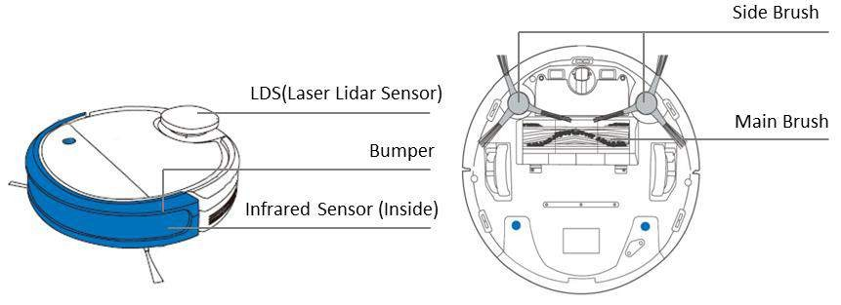

## Onboard Sensors

Vacuum robots are equipped with a range of sensors and beams for object recognition in their path. The infrared beams help sense the proximity of potential obstacles such as a table leg or a rug and avoid collision with these obstacles.

However, avoiding obstacles completely would leave certain areas unclean. Many vacuum robots reduce their movement speed until their touch sensor gently bumps into the obstacle to combat this.

Anti-fall sensors prevent the robot vacuum from falling from high areas as they can detect the height through their sensors.

## Great Accessibility

Cleaning Robots have impeccable accessibility. They can easily slide and navigate under furniture like cots and couches without humans having to lift a finger.

Furthermore, you no longer must move heavy furniture around the house if you wanted to clean every nook and corner. Cleaning Robots can clean by getting into tight spaces without you having to put on your cleaning hat!



## Compact Size and Design

A Cleaning Robots cleaner's compact size and design enable it to reach areas and corners of the room which would otherwise be inaccessible with traditional cleaning methods or with a hand-held vacuum cleaner.

Further, thanks to a minimal and highly functional design coupled with engineering finesse, Cleaning Robots cleaners, like the Robo Vac N Mop, feature several different cleaning modes like spiral, edge, and zigzag so that you can be rest assured that every nook and corner of your space is being tidied up!



# HOW ARE CLEANING ROBOTS MADE UP OF?

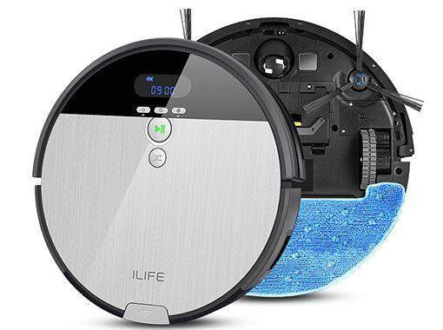

Most Cleaning Robots cleaners use plastic chassis, and they are compact enough to navigate through tight spaces. The power themselves using lithium-ion batteries, and some premium models can deliver up to 120 minutes of run time.

Most Cleaning Robots cleaners use one or two spinning brushes along with a rolling brush. These brushes collect dirt towards the centre of the room, where the electric motor creates suction. Dust, hair, and everything else collected by the vacuum cleaner is sucked and stored into a removable dust container.

Users must manually dump the dust from the container, once it fills up. Some premium models also come with an auto-dumping feature, which automatically disposes of the dust without requiring any human input.

Some models also sport HEPA (High-Efficiency Particulate Air) filters. These filters are designed to remove 99 per cent of airborne particles, so they are very effective at capturing dust, pollens, and allergens. This feature helps reduce allergic reactions.



# MECHANISM OF CLEANONG ROBOTS

Cleaning robots are becoming one of the most popular new home appliances a trusted little cleaning partner in many households unlike the traditional vacuum cleaner. This robot can clean your room by navigating across the floor and avoiding obstacles it also charges itself all without using human help.

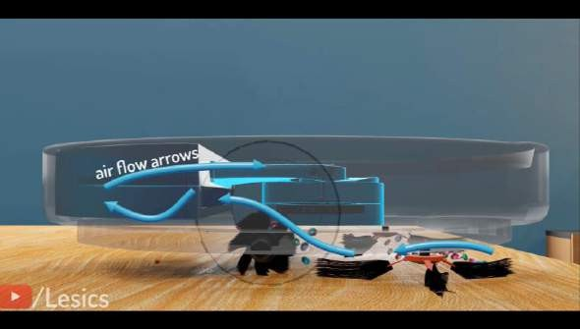

Let’s design an intelligent cleaning robot by stepping into the shoes of a robot developer. The basic component required to collect the debris is this vacuum pump like your normal vacuum cleaner. The two tractor wheels along with a tiny caster wheel help the machine move as the opening length of this vacuum pump is smaller than the diameter of the machine. Additional set of side brushes and a roller brush is needed to clean efficiently these together. Easily direct the debris, it comes across to the suction opening effectively cleaning a bigger area. These two sides brushes are especially helpful when this machine is cleaning a corner.

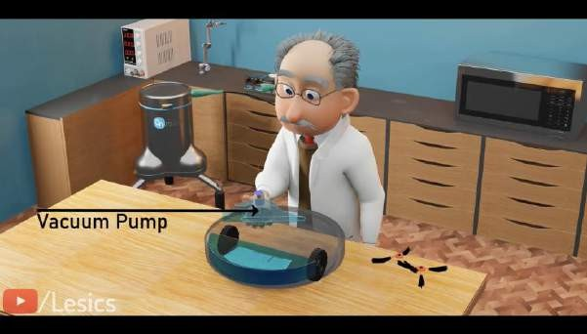

This arrangement becomes more efficient when we attach a clever mopping attachment, the mechanism controls the pressure inside this water chamber and controls the waterflow via the cotton plugs inside, this mopping arrangement can



remove tough stains from the floor, while the mechanism simultaneously collects the debris two in one.

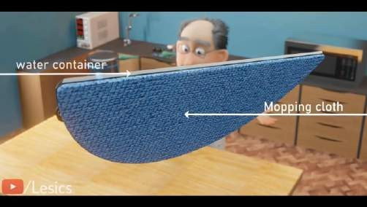

Now this battery-powered mechanism is ready to start cleaning the room, but this cleaning machine unable to detect chair and change its trajectory. Let’s add intelligence to this machine and convert it to a robot through a few stages.

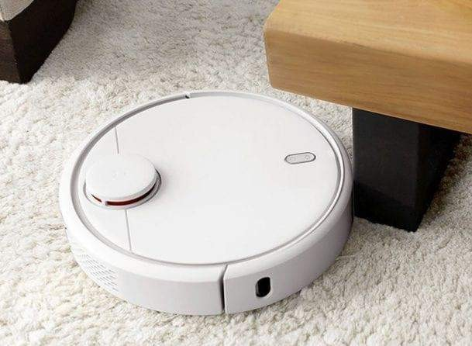

To solve this issue lets attach the optical limit switches to the front hemisphere of this robot. Now every time, the robot hits an object with the help of this bumper cover the limit switch gets operated and generates an electronic signal to process this signal. A smart controller the brain of the robot comes to the rescue this smart controller. Now takes over the individual speed control of the wheels. The motor-controlled wheels turn in opposite directions this allows the robot to take a turn obviously.



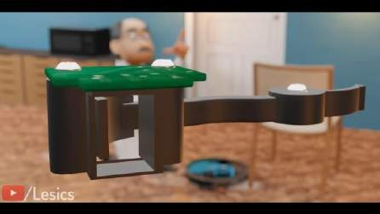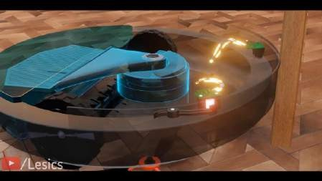

The robot’s random path doesn’t efficiently cover the entire room it consumes more time and power the most efficient path is shown here and to follow this path properly, our robot needs to take proper right angle turns. It also must travel a small distance to avoid overlapping the robot developer in you might have a clear solution add a gyroscope sensor and wheel encoders to the robot. Now when the robot bumps into this wall the gyroscope sensor will help it to take the angular turns accurately and to cover the proper distance. The wheel encoder will come into play by counting the wheels rotation.

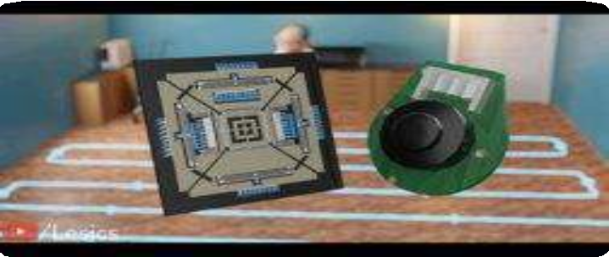

Now although these sensors are enough to clean these room the chair is still a problem. As the robot is unable to differentiate between a chair and a wall and is programmed to take a turn after hitting a wall, our robot will turn and leave the area uncleaned, to increase its intelligence lets add a lidar sensor, this advanced sensor continuously emits lasers with the help of the return pulse the bot measures the distance between the robot and the objects surrounding.

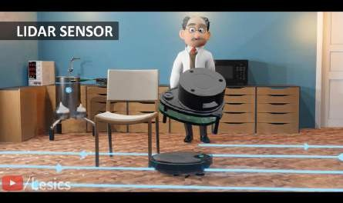

While rotating it creates a 2D map of your room and using a smart algorithm this robot can decide to follow the efficient cleaning path quite easily. So, this robot can now differentiate between the wall and chair we can also integrate a handy mobile application for setting up go and no-go zones on the floor cleaning schedule specific area cleaning as well as many more features.



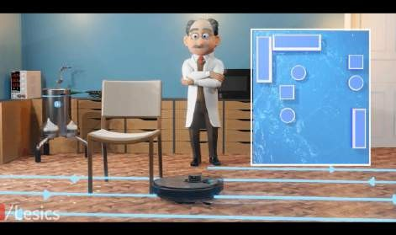

It has no problem climbing up to two centimetres high but if we increase the height further it is unable to do the same. So, two centimetres is the maximum height the robot can climb. Now another challenging situation for the robot staircase situation cannot be detected even by our two-dimensional lidar sensor and quickly cause a sad end to its service.

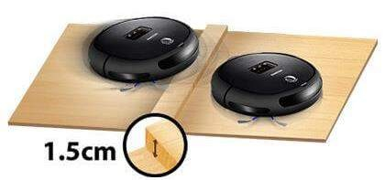

To avoid this situation, we need to place three optical proximity sensors at the edge of the robot, this sensor has an IR light emitter and photo detector. The generated light from the LED gets reflected from the surface and is received by this detector when the bot is in danger of falling down the smart controller. Measures the distance of this reflected light and immediately stops to change the robot’s direction by controlling the motors.

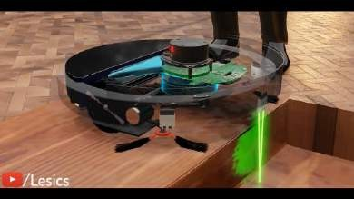

Still robot is having trouble detecting the electric wire this issue is not discovered by the lidar sensor, because it is a 2d detector because of this it can also fail to recognize objects like clothes, toys, pet waste etc.



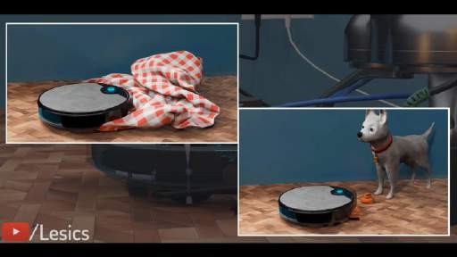

Let’s attach a camera along with an inbuilt 3D depth sensor in front of the robot. It maps its front region in 3D and avoids this obstacle so this sensor is efficient in detecting the obstacles precisely but cannot map the entire room, so introducing sensor fusion technique using both the lidar and camera system together and combining their data to get more accurate cleaning paths.

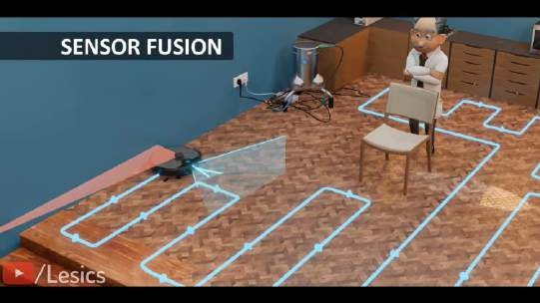

Now when the robot needs to juice up itself you don’t have to plug the charger into it instead it will automatically retrace its steps back to its starting point at the charging dock and start recharging the battery. The hassle-free cleaning starts now.

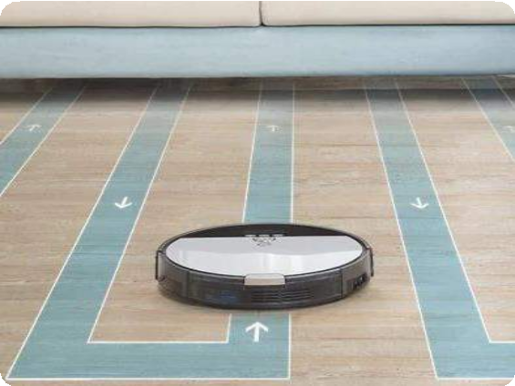

# HOW DO CLEANING ROBOTS NAVIGATE?

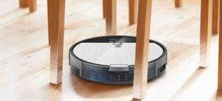

Cleaning Robots cleaners automatically navigate themselves through spaces using obstacle and cliff sensors. Obstacle sensors are usually located on the Cleaning Robots bumper, and they are designed to avoid obstructions such as chair and table legs, sofas, toys and everything else in the cleaner’s path.

Cleaning Robots cleaners steer themselves away from obstructions when the obstacle sensors are triggered. They are programmed to rotate and move forward until the device finds a clear path. The direction robotic cleaner takes are determined by where the bumper makes contact. For example, if a vacuum cleaner detects an obstruction on its left bumper, it moves to the right side to avoid the object. Many premium models even use laser sensors to avoid objects in darker rooms.

Cliff sensors act as a safety mechanism for Cleaning Robots cleaners. These sensors tell the vacuum cleaners when they reach a drop, like an edge of a step. Cliff sensors are located at the bottom of the cleaner. They measure the distance between the cleaner and the floor, by constantly sending infrared signals to the surface. If the signal doesn’t bounce back immediately, the vacuum cleaner detects that it has reached a stair or a steep drop.



Most robotic cleaners operate using obstacle and cliff sensors, but some premium models also use additional wall and wheel sensors for more efficient cleaning. As the name suggests, they can detect walls and find straight lines that robotic cleaners can follow. These sensors allow the cleaner to clean along the edges where the wall meets the floor. These sensors are placed on the sides of the cleaner, so the cleaner can evenly pick dirt from tight corners, without bumping or scuffing the wall. These sensors also allow the cleaners with mapping abilities to discover new areas to clean. Wheel sensors track the moments of the wheels, so robotic cleaners can analyse distances and turns made. These sensors allow the cleaners to know their precise location, and this gives them the ability to navigate better.



# MAIN FEATURES OF CLEANING ROBOTS

Cleaning Robots has different types of cleaning modes, usually include the following:

* **Auto**: This mode is helpful for general cleaning. Usually, the mode cleans a space until the battery runs out.
* **Spot**: with the help of this mode, the vacuum focus on a particular dirty zone.
* **Turbo**: This mode is used to clean and pick up the most dirt and dust, but it may create noise.
* **Edge**: This mode helps to clean edges & corners.
* **Quiet**: The mode helps to reduce noise levels while cleaning. It's helpful when you are at home.
* **Remote control**: It allows the user to control the direction of the vacuum.

## Wet mopping

Some models can also mop for wet cleaning, autonomously vacuuming and wet mopping a floor in one pass (sweep and mop combo).

The mop is either manually wetted before attachment to the bottom of the robot or the robot may be able to automatically spray water on to the floor before running over it.

Some advance robot vacuum cleaners have a sensor that detects and avoid mopping in carpeted areas. However, if there is no sensor, most of the robot vacuum cleaner manufacturers adding no-mop zone feature in the app nowadays to make robot vacuums to avoid certain areas from mopping. These robot vacuums are also capable to mop about 150sqm in one go.

A Robot Mop can tackle multi surfaces and comes with a variety of different cleaning modes giving you options of sweeping, vacuuming and mopping damp or wet floors. The Robot Mop score better on hard floors surface and are ideally suited for hardwood, laminate and tile flooring types



## Mapping

The first Cleaning Robots used random navigation. This sometimes caused the unit to miss spots when cleaning or be unable to locate its base station to recharge and did not provide the user a history of which spaces were cleaned.

More sophisticated models include mapping ability. The unit can use gyro, camera, radar, and laser ([laser distance sensor](https://en.m.wikipedia.org/wiki/Laser_distance_sensor) or LDS) guided systems to create a floor plan, which can be permanently stored for more efficiency, and updated with information on areas which have been (or have not been) cleaned. Thus, the cleaning efficiency is greatly improved, and the repetition rate is reduced significantly.

Models with a multiple floor plan feature can store several floor plans.

## Others

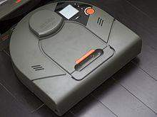

D-shape vacuum cleaner

**Anti-drop:** Most robots include anti-drop and anti-bump [IR sensors](https://en.m.wikipedia.org/wiki/Passive_infrared_sensor). **Anti-winding:** When approaching obstacles, will automatically turn away. **Anti-twining:** Prevents the robot getting twined by wires.

**Virtual No-Go lines:** Virtual No-Go lines set boundaries, to restrict the unit's movements to desired cleaning areas.

**Quick recharge:** Most robot vacuums come with a Lithium-ion battery of around 2000 mA that will last long enough to handle approximately 200 m2 of floor space (about 100 minutes). Regular charge time is 5 to 6 hours. Quick recharge allows the



unit to calculate the shortest way to recharge (shortcut path) and charge only as much as needed, so it finishes more quickly (automatic cleaning resumption).

**Schedule:** Scheduled daily cleaning. All-Timetable means a full week of different daily schedules can be programmed.

**Connected app**: Some models allow control of the unit using an app over a Wi-Fi connection, from your smartphone or connected home automation device,

e.g. [Amazon Alexa](https://en.m.wikipedia.org/wiki/Amazon_Alexa) and the [Google Assistant](https://en.m.wikipedia.org/wiki/Google_Assistant).

**Software upgrades:** Some units are able to receive [over the air](https://en.m.wikipedia.org/wiki/Over-the-air_programming) (OTA) firmware updates.

**HEPA Filters:** [HEPA](https://en.m.wikipedia.org/wiki/HEPA) air filters are industry standard now for robot vacuum cleaners. These remove dust and pollen from the air.



# ADVANTAGES

If you have ever wondered why, you should consider buying a robot vacuum, here are ten of the most common benefits associated with using these autonomous cleaning devices.

## No Need for Manual Operation

If you suffer from mobility issues or physical ailments, a robot vacuum is the perfect cleaning device for you. Not only does it improve your cleaning routine, but it does so without putting in any extra strain on you or your situation. Simply turn it on and let it clean.

These devices contain various sensors, which allow it to clean independently. This eliminates the need to stand, walk, and bend over for extended periods of time. Cleaning Robots are also great for elderly individuals who may be suffering from arthritis or joint pain. Many of these vacuums can be present to clean when needed, and they typically require very little maintenance.

## No Time, No Problem

In our busy and, oftentimes, overwhelming world, many consumers are charged with the task of raising families, building a career, and maintaining an active social life. These daily activities, obviously, take precedence over cleaning, which in turn creates a pressing need for a quick and convenient way to vacuum.

Since Cleaning Robots can clean on their own without any supervision, they can save you an astonishing amount of time. This is the perfect vacuum cleaner for all the busy folks. Because you don’t have to oversee these devices, you can turn them on before you leave the house. Some models even allow you to use a smartphone or tablet to activate it when you’re not even home. This allows you to devote more time to activities that you love and enjoy, yet still come home to a clean home.

## Automatically Adjusts to Different Surfaces

Different floor surfaces require different vacuum settings. Therefore, many robot vacuums are equipped with sensors that detect changes in floor surfaces. There is no



need to think about carpet, wood, and tile when you use these machines; they automatically adjust. They can also detect stairs and walls, automatically steering away to prevent unintentional damage to the unit.

## Adjusts Cleaning Settings

For many homeowners, some floor areas are dirtier than others. In general, areas that receive the largest amounts of foot traffic, such as foyers, kitchens, and living areas, tend to be the dirtiest. Therefore, many Cleaning Robots are endowed with the ability to detect the amount of dirt in a specific area, enabling them to automatically adjust their cleaning settings. The dirtier an area is, the more time the unit will spend cleaning it.

## Self-Charging

Since robot vacuums can recharge themselves, there is no need to worry about manual recharging. After completing a task, the vacuum will immediately return to its docking station. This means that if your battery is low, it will automatically be recharged after each cleaning. Or some units will even stop its cleaning process and go dock itself to recharge.

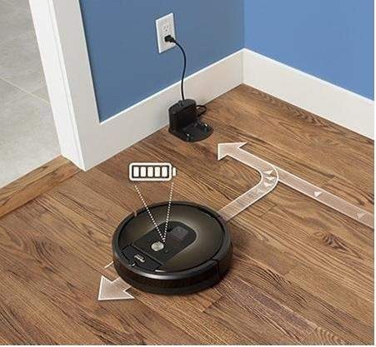



## Can Clean When You Aren’t Home

Wouldn’t it be great if you could clean your house while you were away? Now you can, with a bit of help from a Cleaning Robots. While we already discussed how it can help those with little time for vacuuming, it’s worth pointing out that some robot vacuums can be programmed to automatically start cleaning at specified times of the day.

Aside from the initial set up, you are completely hands-off. This can be especially helpful during vacations, business trips, and other occasions where you will be away from home for extended periods of time. This is one of the main reasons why you should consider buying a robot vacuum.

## Detects Present Boundaries

One of the main concerns I’ve heard about robot vacuum cleaners, is that they will fall down the stairs, damage walls or knock over other decor. This is really an unnecessary fear since you can set virtual walls.

The virtual wall feature creates boundaries that your device will not be able to cross, removing the threat of broken machines or damaged furniture. It also prevents the machine from going outside or into off-limits areas of your home.

## Low Maintenance

When compared to manual vacuums, Cleaning Robots cleaners require only a minimal amount of maintenance. These machines are typically constructed of higher quality materials and are built to serve you for years to come.

Your only job is to periodically replace the bag or empty the container, as well as keep your floor clear of clutter and other potentially damaging objects. These are the only two maintenance tasks that you will be required to perform during the life of your machine.

## Fits into Tight Spaces

Many consumers complain about not being able to vacuum in hard-to-reach or tight spaces, but once you purchase a Cleaning Robots, this problem will disappear



completely. Due to their compact size, Cleaning Robots can clean smaller spaces that are typically off-limits to manual vacuums.

These areas include all the corners, nooks, and crannies that your traditional vacuum may not be able to get to without using an extension of some kind. When you employ a robot vacuum, your floors will receive an extensive and thorough cleaning in a relatively short period of time.

## They Save Cleaning Time

One of the major advantages of having a Cleaning Robots is that it frees up time otherwise spent cleaning. With one of these in your home, you can spend time doing what’s most important to you and still be assured that your home is clean. Furthermore, because you can program the robot vacuum cleaning schedule, it won't get in your way when you're trying to get other stuff done.

## They Can Clean Underneath Furniture

Cleaning is never fun but kneeling or raising furniture to clean underneath them makes the cleaning experience much worse. Cleaning Robots come in handy in these situations. Their small sizes allow them great manoeuvrability, such that they can easily clean underneath beds and sofas.

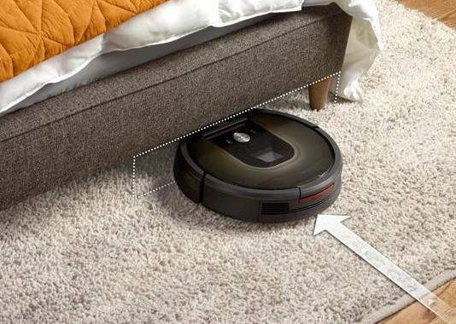

## They Can Be Used for Emergency Cleaning

We’ve all had those days when you don't feel like cleaning. Which usually ends up with us giving a bad impression of ourselves when we have unexpected guests. A Cleaning Robots cleaner can be a reputation saver at times like this!

* + Cleans without Human Interference with the advanced feature that will let you set Cleaning Robots cleaner to vacuum the whole floor of your home while you are not at home, you are sure of meeting a neat floor by the time you get back home. Cleaning Robots cleaner is also an excellent cleaning device for people who undergo mobility problems.

[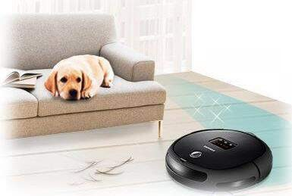](https://www.zelect.in/vacuum-cleaner/vacuum-cleaner-selector)

* + Cleaning Robots cleaner are convenient and saves time. The fact that Cleaning Robots cleaner saves time and effort to get your floor cleaned, is apparently one of the notable strengths of this vacuum cleaner. You will have to do the cleaning yourself, if it were to be a manual vacuum cleaner. Once you set it and switch it on, it will complete the rest of the job, leaving you to tackle other important assignments or even relax reading your favourite magazine or watching an interesting movie.
  + Cleaning Robots cleaner cheap to Maintain in India. Once you get rid of dust particles in your Cleaning Robots cleaner and give it thorough cleaning, it needs just minimal maintenance. Once you maintain it well, it will last long without having to spend huge amount maintaining it. There are even some models that will recharge themselves



when vacuuming is completed. Hence, your Cleaning Robots cleaner will charge itself for you, even if you forget to do so.

## Other Benefits

Cleaning Robots, especially the more expensive models, offer a wealth of benefits to consumers. Many of these models claim to offer better cleaning features than traditional models. A few of these technologically advanced features include:

### Larger Dust Bags:

Since your bags can hold a larger amount of dirt and debris, they will need to be changed less often than the bags in manual vacuums. That’s assuming your unit even requires a bag, some have a container that makes it even easier to empty.

### Longer Lifespan:

Because they require less maintenance, robot vacuums have a reputation of lasting longer than other types of vacuums. This won’t always be the case, as some brands and models are better than others. But these units will last for a long duration of time.

### No Cords to Deal With:

These vacuums come with their own recharging stations. Not only does this make it easier for you, but it also means you never have to deal with tangled cords in the way of where you need to clean.

### Smart Home Connectivity:

Just like many smart home appliances, many robot vacuums can stay connected to your home Wi-Fi, allowing you to control it remotely with a smartphone or tablet. Now, you don’t even have to be home to clean your house!



# DISADVANTAGES

Cleaning Robots have proven to be an invaluable tool for people with mobility issues and for those who just hate vacuuming by themselves. But as helpful as they are, they are not without their limitations.

## They’re Not Entirely Hands-off

A Robot vacuum isn't as hands-off as you’d expect. They still require human assistance because they get stuck a lot. Not only that, but they also tend to get stuck under things like furniture and doorways or snag on other objects.

The chances of your robotic vac getting stuck while cleaning and requiring your attention are very high, especially if you leave stuff lying around in the house. Plus, some models also require manual intervention when they need to be emptied.

## They’re Expensive

Cleaning Robots are more expensive than standard vacuums. This is because they require extra technology to function, such as sensors, computer brains, and a complicated cleaning system.

A Cleaning Robots cleaner can be anywhere from $200-$1000, while you can pick up a decent regular vacuum for less than $100. Cleaning Robots also have a higher repair cost due to the complex technology that goes into them.

## They Don't Work Well on Carpeted Surfaces

Cleaning Robots cleaners are not as effective on carpeted surfaces because they can't move and glide easily. Some models have a habit of becoming stuck in the carpet fabric, which causes them to stop working.

In addition, it can be hard for these vacuums to differentiate between clean and dirty areas on carpets because of their shaggy nature.



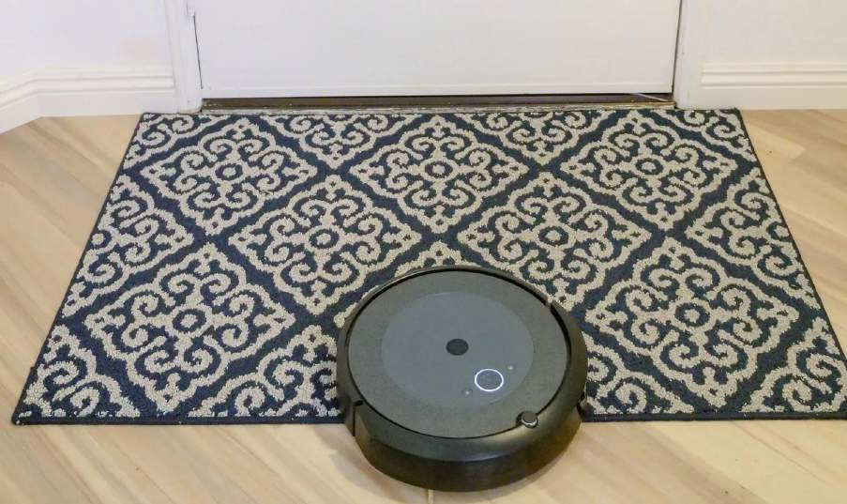

## They Don’t Clean as Well as a Traditional Vacuum Cleaner

Cleaning Robots don't pick up as much dirt and debris as a standard vacuum cleaner. They usually have a smaller intake, meaning they don't suck up large amounts of dust from the floor. Furthermore, depending on the shape of your room, your robot vacuum won't make it into the corner, as it simply cannot reach.

## They May Dent Furniture

Cleaning Robots cleaners are programmed to bounce back after hitting obstacles and may chip away paint at the edges of doors and furniture if they hit them frequently.

## Others

* + Cleaning Robots cleaner short battery life Cleaning Robots cleaner come with short battery life and in some cases, they will not be able to complete the cleaning assignment. It is more or less than 2 hours per charge and can take some hours or more to recharge. It is not a vacuum cleaner for extensive vacuuming. As a result of this shortcoming, make sure you do a thorough finding about the technicalities of the Cleaning Robots cleaner and consider what the type of cleaning you will subject the machine to, before you buy one.



For instance, it is recommended that you a go for a Cleaning Robots cleaner with long battery life, and large dust capacity, if you have many floors that require hoovering.

* + Poor cleaning as far as robotic cleaners are concerned, you get poor quality of cleaning if you buy invest your money on a bad Cleaning Robots cleaner.
  + Costly Without doubt, Cleaning Robots cleaner of good quality is expensive. The more features a Cleaning Robots cleaner gets, the costlier it becomes. As a matter of fact, quality Cleaning Robots cleaners are more expensive than the available vacuum cleaners on the market today.
  + Long Time of Cleaning Robots cleaner spends longer time to clean the floor of a room due to how it functions. In addition, it will not be capable of holding a large amount of dirt due to its small size. However, if you have small rooms, this will not constitute any problem for you.

[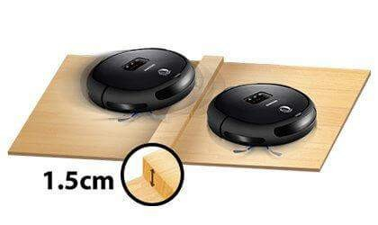](https://www.zelect.in/vacuum-cleaner/vacuum-cleaner-selector)

* + Cleaning Robots Cleaner is not Unconquerable Cleaning Robots cleaner is not unconquerable, despite the fact it is particularly premeditated to negotiate around the obstructions in a room. As a matter of fact, Cleaning Robots cleaner can be clogged up easily by things like buttons, string, large pieces of paper and lots more.



# APPLICATIONS

## Disinfection Robots

There are several benefits to using robots for disinfection. They are faster and more thorough than humans, safer to use, and can even improve patient access to expensive equipment.

### Speed and Effectiveness

Many commercial cleaning robots use Ultra-Violet (UV) radiation to disinfect surfaces. Studies have shown the effectiveness of UV radiation in killing viruses and bacteria. Because this is a “touchless” method of cleaning, it is faster than manual methods involving wiping with a cloth.

The technology is available and there are multiple vendors from which to choose.

At the Sharp Grossmont Hospital in San Diego, all COVID patient rooms are disinfected daily by cleaning robots. According to an [article in the Washington Post](https://www.washingtonpost.com/technology/2020/09/08/robot-cleaners-surge-pandemic/), they can do it in 12 minutes and more thoroughly than workers can do in 90 minutes. In addition, robots can disinfect hard-to-reach surfaces more effectively than humans.

### Safety

Cleaning and disinfection robots help to keep cleaning personnel safer. With robots doing the dirty work, cleaning people do not have to touch cleaning fluids or contaminated surfaces.

Airports use UV disinfecting robots to clean surfaces, handrails, and areas often touched by people's hands. Such cleaning is an enormous job and carries potential risk if done by human workers.

### Improve Patient Access to Equipment

In some cases, cleaning robots enable patients to have better access to equipment. For example, in radiology, unskilled cleaning people are not allowed to touch the expensive



equipment. So, the radiology staff must do the cleaning. The time needed for cleaning has caused significant delays in scheduling appointments for patients to receive tests.

The ultra-violet (UV) radiation cleaning robots can disinfect radiology equipment without touching it. And it can be done much faster - from two to four times more quickly than by manual methods, according to [a research article published in January](https://www.frontiersin.org/articles/10.3389/frobt.2020.590306/full) [2021](https://www.frontiersin.org/articles/10.3389/frobt.2020.590306/full).

### Spraying of Disinfectants

Another approach is to have the robot use disinfecting sprays. Some UV robots have an optional spraying attachment enabling them to create a fog of hydrogen peroxide. But this requires no people to be around, and that may not always be practical.

## Floor Cleaning Robots

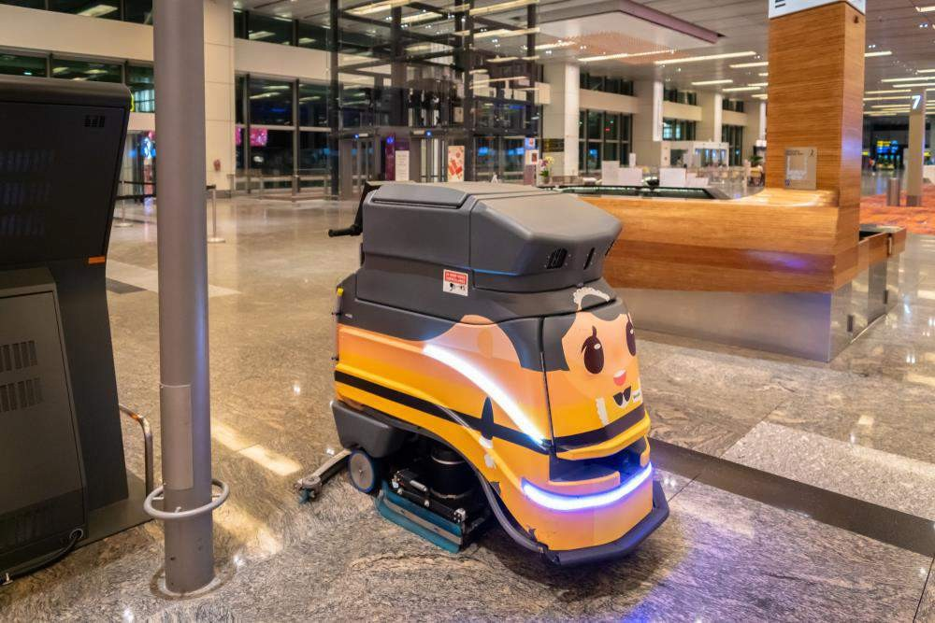

Robotic floor cleaners have become well established. They can mop, vacuum, and polish floors autonomously.



The pandemic has made the public much more conscious of cleanliness. For many people, it has become the essential factor in deciding where to eat or stay overnight. Thus, cleaning robots are beneficial for restaurants, hotels, and convention centres, not only because they help keep things cleaner and relieve the burden on staff.

Robotic floor cleaners are labour-saving machines, but they cannot run entirely independently. An operator must still replace cleaning fluids and empty the dirty water container on mopping robots. A worker must empty the dustbin of vacuum cleaning robots. Someone must teach the floor plan to the bot. Usually; this involves an operator guiding the machine around the facility. Once the floorplan is learned, the robot can travel independently.

[Request offers for floor cleaning robots from suppliers.](https://www.howtorobot.com/get-quotes)

## Bathroom Cleaning Robots

The market for robots that can clean bathrooms is still in its infancy. There are cleaning solutions that offer a "touch-free" system. It is a multifunction machine that starts with a power spray. The next step is a vacuum that removes the dirty water.

Finally, the device uses a blower to dry things off. All of this is included in one compact machine. Undoubtedly this saves labour, and it saves workers from having to stoop over and scrub. But the device must still be used by a cleaning person.

For a truly autonomous solution, there appears to be only one vendor at the time of this writing. The robot follows the three-step process described above. But it does so without the need of a human. Videos show the robot spraying and vacuuming a bathroom by itself. It has a [robot arm](https://www.howtorobot.com/expert-insight/robotic-arms) that can change tools.

So, it can use a power-sprayer, a vacuum, and a brush. It would appear the robot arm cannot reach behind the toilet. The robot has a limited ability to manage variations in toilets and urinals. It is advertised as a monthly service rather than as a purchase.

There is market potential for more vendors to provide bathroom cleaning robots, so it seems likely that we will soon see new suppliers.

## Pool Cleaning Robots



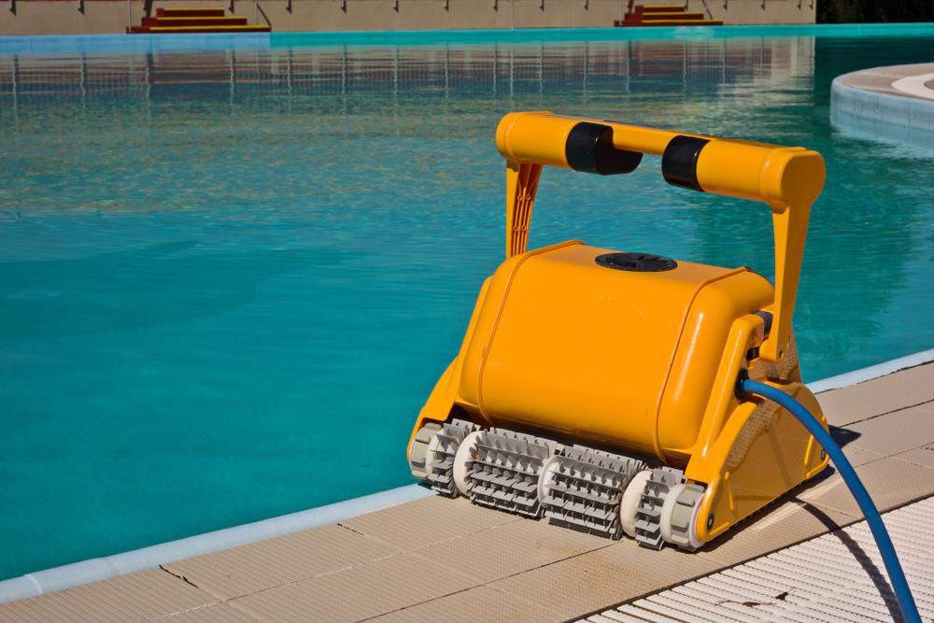

Robotic pool cleaning is an established technology, and there are various vendors from which to choose. The robots have intelligent navigation that allows them to cover the entire pool. They are equipped with brushes to clean away dirt, debris, and algae. Some offer remote control.

For large pools, commercial pool cleaners have an electrical cord to supply power. There are battery-powered models available which offer various runtimes between charges.

However, human intervention is still needed. Pool cleaning robots must be cleaned by an operator. They collect debris and gunk in a container that must be emptied.

[Request offers on pool cleaning robots from suppliers.](https://www.howtorobot.com/get-quotes)

## Street Cleaning and Garbage Collecting Robots

In outdoor applications, most of the solutions are still in their beginning stages. Garbage collection robots for cleaning beaches and parks are beginning to appear. But most of the solutions are not autonomous. Instead, they are remotely piloted by an operator who can be up to 300 meters away.



Autonomous street cleaning robots are being evaluated, and pilot projects have shown promising results. However, the safety certifications are not yet there.

There are floating robots that collect garbage and clean rivers and bodies of water. They are also still in the preliminary stages. Most such robots are cleaning machines run by people.

## Solar Panel Cleaning Robots

There is a debate about how often solar panels need to be cleaned. A consensus seems to be every six months. Of course, this depends on your location. One thing is certain: the efficiency of solar panels goes down when they become dirty. Having a low-cost way of cleaning the panels is vital.

Walking on top of solar panels would damage them. And often, the panels are found on rooftops or other hard-to-reach locations.

Robotic solar panel cleaning solutions are in operation worldwide, and there are numerous vendors offering solutions. In desert areas, the robots use a dry system with brushes or using a microfiber cloth. There are solar panel cleaning robots that carry a tank of fluid for cleaning. Still others have a tube that carries the cleaning fluid to the unit. Some models can travel along tilted panels.

Most such solutions offer only a degree of autonomy. An operator is needed to oversee and often remotely control the unit.

Sometimes, a crane may be needed to hoist the robot into position.

## Robotic Window Cleaners

You've possibly already outsourced your window cleaning to a window cleaner, but why not save a lot of money (and clean the indoor windows) with one single investment: a robotic window cleaner. These work the exact same way as the Cleaning Robots cleaners by driving around and using sensors to navigate, but the big difference is that they use suction in order to attach themselves to your [glass](https://www.openpr.com/wiki/global-glass-market) so they can move around on the vertical surfaces.



# THE FUTURE OF SELF-CLEANING ROBOTS

* While robotic and sensor technologies continue to develop, commercial industries like hospitality may begin utilizing these types of robots to keep their guests and employees safe in the future.
* Moreover, the latest trend in autonomous cleaning is not just based on independent cleaning robots.
* Rather, these robots can be a part of the connected and intelligent cleaning system with well-defined behaviour, with an ability to adapt to the changing environment and dynamics of the area under cleaning.
* Over time, cleaning crews will be able to work alongside and monitor robots to do the dirty and repetitive tasks that will keep us safe from harmful germs.
* Dominated by house-cleaning robots, the global consumer service robotics market posted 25 per cent shipment growth (year-on-year) last year, a report showed on Tuesday.
* The consumer robot market is estimated to grow at a compound annual growth rate (CAGR) of 27 per cent over the next four years, according to Counterpoint's IoT service.
* "House cleaning robots, which mainly comprise robot vacuums, is the most dominant category in the robotics industry, capturing over two-thirds of the total consumer service robotics market," said senior research analyst.
* Covid-19 has positively impacted the robot vacuum industry, resulting in increased demand from residential users.
* With advances in AI, the prices of components and software are also coming down, making the robots more affordable.
* Within the consumer robotics market, the personal and education category is set to take the highest share of 54 per cent by 2025.



* "The category offers the best near-term opportunity due to the rising need for elderly care (especially in combatting isolation), social security and new ways of learning for children," said Research VP Peter Richardson.
* "We estimate that the market opportunity of Personal and Education robots will exceed $4.5 billion by 2025 with substantial further growth expected beyond 2025 due to the ageing population in many countries and increasing focus on STEM-based learning," Richardson added.
* Personal and education robots had the lowest average selling price (ASP) of around $279, followed by house cleaning robots ($626).
* In the house cleaning category, the leading players are iRobot, Ecovacs, and Roborocks.
* The consumer service robots market holds tremendous potential in the coming years due to evolving use cases, the report noted.
* Medical robots still seem a risky proposition as they need a lot of upfront capital expenditure, and the R&D outcomes are unpredictable.

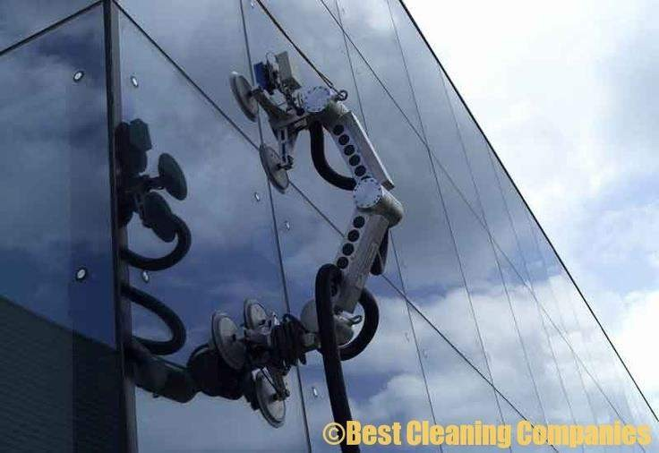

# CONCLUSION

With technology playing a big part in the cleaning industry, it will help to enhance the productivity of cleaning operations and protect the hygiene level of the environment much more effectively.

House cleaning robots, which mainly comprise robot vacuums, is the most dominant category in the robotics industry, capturing over two-thirds of the total consumer service robotics market.

Cleaning Robots take pride in ensuring clean and well-maintained spaces in commercial and residential facilities. With the use of autonomous robots and innovative cleaning solutions, we can provide a wide range of cleaning in many areas including airport facilities, warehouses and retail spaces. Our sophisticated cleaning techniques and eco-friendly supplies also extend to [residential cleaning services](http://sq1.com.sg/services/contract-cleaning/#residential-cleaning) to help maintain clean, healthy homes.

These Cleaning Robots become advance in future and can clean tall glass buildings without human intervention. These Cleaning Robots play a major role in Ships Cleaning, Pool Cleaning, Roads Cleaning etc.



# REFERENCES

* <https://learn.compactappliance.com/benefits-of-robot-vacuums/>
* <https://www.makeuseof.com/how-does-a-robotic-vacuum-work/>
* [https://www.zelect.in/vacuum-cleaner/advantages-and-disadvantages-of-](https://www.zelect.in/vacuum-cleaner/advantages-and-disadvantages-of-robotic-vacuum-cleaners) [robotic-vacuum-cleaners](https://www.zelect.in/vacuum-cleaner/advantages-and-disadvantages-of-robotic-vacuum-cleaners)
* [https://www.google.co.in/amp/s/m.timesofindia.com/most-searched-](https://www.google.co.in/amp/s/m.timesofindia.com/most-searched-products/electronics/buying-guide/all-you-need-to-know-about-robot-vacuum-cleaners-buying-guide/amp_articleshow/70434519.cms) [products/electronics/buying-guide/all-you-need-to-know-about-robot-](https://www.google.co.in/amp/s/m.timesofindia.com/most-searched-products/electronics/buying-guide/all-you-need-to-know-about-robot-vacuum-cleaners-buying-guide/amp_articleshow/70434519.cms) [vacuum-cleaners-buying-guide/amp_articleshow/70434519.cms](https://www.google.co.in/amp/s/m.timesofindia.com/most-searched-products/electronics/buying-guide/all-you-need-to-know-about-robot-vacuum-cleaners-buying-guide/amp_articleshow/70434519.cms)
* [https://blog.tensorflow.org/2020/01/ecovacs-robotics-ai-robotic-](https://blog.tensorflow.org/2020/01/ecovacs-robotics-ai-robotic-vacuum.html?m=1) [vacuum.html?m=1](https://blog.tensorflow.org/2020/01/ecovacs-robotics-ai-robotic-vacuum.html?m=1)
* [https://www.reliancedigital.in/solutionbox/the-workings-of-robotic-vacuum-](https://www.reliancedigital.in/solutionbox/the-workings-of-robotic-vacuum-cleaners/) [cleaners/](https://www.reliancedigital.in/solutionbox/the-workings-of-robotic-vacuum-cleaners/)
* [https://www.google.co.in/amp/s/www.dqindia.com/3-self-cleaning-robots-](https://www.google.co.in/amp/s/www.dqindia.com/3-self-cleaning-robots-helping-reduce-germs-hotels/amp/) [helping-reduce-germs-hotels/amp/](https://www.google.co.in/amp/s/www.dqindia.com/3-self-cleaning-robots-helping-reduce-germs-hotels/amp/)
* [https://www.google.co.in/amp/s/www.indiatvnews.com/amp/technology/ne](https://www.google.co.in/amp/s/www.indiatvnews.com/amp/technology/news/house-cleaning-robots-are-leading-the-global-consumer-robotics-market-report-2022-08-02-796874) [ws/house-cleaning-robots-are-leading-the-global-consumer-robotics-market-](https://www.google.co.in/amp/s/www.indiatvnews.com/amp/technology/news/house-cleaning-robots-are-leading-the-global-consumer-robotics-market-report-2022-08-02-796874) [report-2022-08-02-796874](https://www.google.co.in/amp/s/www.indiatvnews.com/amp/technology/news/house-cleaning-robots-are-leading-the-global-consumer-robotics-market-report-2022-08-02-796874)
* [https://www.sq1.com.sg/the-use-of-technology-and-robots-for-commercial-](https://www.sq1.com.sg/the-use-of-technology-and-robots-for-commercial-cleaning/) [cleaning/](https://www.sq1.com.sg/the-use-of-technology-and-robots-for-commercial-cleaning/)
* <https://en.m.wikipedia.org/wiki/Robotic_vacuum_cleaner>
* [https://www.eurekaforbes.com/blog/robotic-vacuum-cleaner-advance-](https://www.eurekaforbes.com/blog/robotic-vacuum-cleaner-advance-technology.html) [technology.html](https://www.eurekaforbes.com/blog/robotic-vacuum-cleaner-advance-technology.html)
* [https://www.howtorobot.com/expert-insight/cleaning-and-disinfection-](https://www.howtorobot.com/expert-insight/cleaning-and-disinfection-robots) [robots](https://www.howtorobot.com/expert-insight/cleaning-and-disinfection-robots)
* <https://www.openpr.com/wiki/robotic-vacuum-cleaner-market>

